

Masafat For Specialized Transport Company
Public Shareholding
Amman - The Hashemite Kingdom of Jordan

The Twenty Annual Report of
The Board of Directors and the Financial Statement

Ending 31/12/2025

P.O.box: (144500) Amman 111814
Tel: 06 (5854263) – (5853257) – (5814667)
FAX: 06-58142817
www.masafat.jo

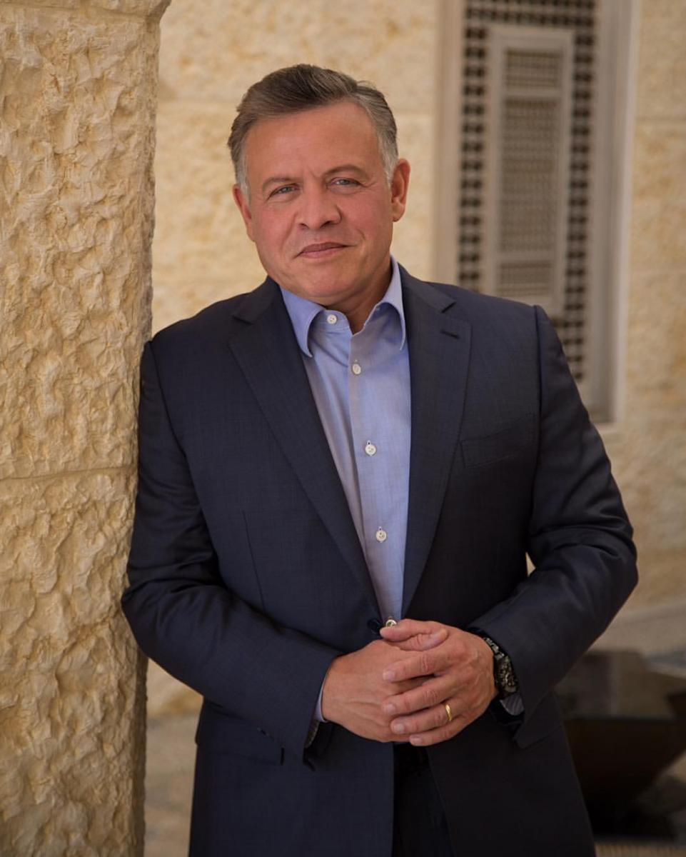

His Majesty King Abdullah II Bin Hussein
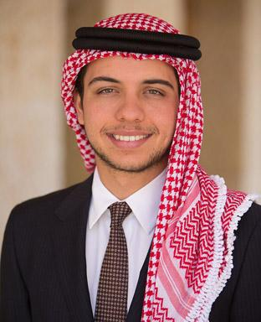
His Royal Highness Prince Al-Hussein bin Abdullah II, Crown Prince
The Board of Directors

Members
Messers Suhail Jamil Muasher and Brothers Company is represented by his
Dr. Marwan Jamil Essa Al-Muasher ,Chairman of Board of Directors

Eng. Raja Khalil Ibrahim Al-Al-Alami, Vice Chairman of the Board

AL Rouche for Investments and Trading Company represented by Mr. Khalil Anis Khalil Naser, Member

Mr. Jawdat Khalil Ibrahim Al-Alami Member
Mr. Emad Hamza Nadim AL Khalil Member
Mr. Anas Mahmoud Al-Chalabi Member
Mr. Mansour Akram Badawi Al-Alami Member

Messers Ready-Mix Concrete and Construction Supplies Company is represented by Eng. Makram Khalil Ibrahim Al-Alami Member

Dr. Jack Nicolas Yaqoob Kattan Member

In the Name of Allah, Most Gracious, Most Merciful

Dear Sirs / Shareholders of Masafat Specialized Transport Company,
Greetings and respect,

Your company was affected in 2025 by the repercussions of crises and wars in neighboring countries, as revenues increase due to the decline in transportation business in all sectors, including the tourism rental sector. Despite this, your company was able to maintain good results, achieving net profits after tax of 1,293,607 dinars in 2025 compared to 1,062,787 dinars in 2024, a increase of 21.72%, resulting from revenues of 32,470,305 dinars in 2025 compared to 32,470,305 dinars in 2024, a increase of 0.37%.
The company is constantly working to enter and win various transportation tenders to expand the company’s business. It is also working diligently to reduce the costs of spare parts and maintenance. Therefore, the company is updating its fleet and replacing old vehicles with new ones to reduce maintenance costs.

We expect that the year 2026 will be a year of goodness and blessings, as there are positive economic indicators that support these expectations.

On my own behalf and on behalf of the members of the Board of Directors, I extend my sincere thanks to all the shareholders of the company, the Companies Control Department, the Securities Commission, the company’s clients and all the company’s employees for their dedication to work, praying to God to preserve Jordan, the King and its people, and to prolong the life of His Majesty King Abdullah II Ibn Al Hussein.
Respectfully,
H.E. Dr. Marwan Al-Mu'asher
Chairman, Board of Directors

Report of the Board of Directors, the Twenty Ordinary General assembly
At the annual meeting held Tuesday on 21-04-2026
Dear honorable Shareholders…
The Board of Directors is pleased to present its report indicating the financial statement according to the company’s law.
1-A-The Accordance Main activities of the Company:
The company’s main activity is focused on the specialized transportation that is related to the ready-mix concrete industry in terms of transporting aggregate, sand, cement, and water. This is in addition to transporting Containers, Fuel, Water, Dumpers, and garbage compactors.
1-B-The company’s geographical locations and the number of employees in each of them:
The company’s head office is located in:
Bayader- industrial area near Kingdom Concrete headpuaters
P.O.box: (144500) Amman 111814
Tel: 5854263 – 5853257 - 5814667
FAX: 58142817
Website: www.masafat.jo

The company’s fleet is distributed in Aqaba, Irbid, Sahab, Azraq, Bayader, Shafa Badran, Qastal, Ghor, Karak, Qatrana and Ma’an.
Number of employees (507) registered on 31/12/2025, are divided into:
Branch Name | Address | Number of employees
Main Center | Amman | 169
Dead Sea branch | Sweimeh | 4
Aqaba branch | Al-Mameel | 7
Ramtha branch | Ramtha | 112
Azraq branch | Al-maamel bricks | 14
Sahab branch | Mercedes circle | 11
Qastal branch | Station | 116
Shafa Badran branch | Shafa Badran Area | 14
Ma’an branch | Maan Area | 6
Karak branch | Karak Area | 4
Bromine | Gore | 54
Mafraq branch | Mafraq Area | 1
Marka branch | Marka area | 9
Al Muqabalayn branch | Al Muqabalayn area | 15
Hashemiya branch | Hashemiya Azraq area | 66
Masfah branch | Hashemiya Azraq area | 5
total | 507

C- Company Total capital investment:
The Total capital investment am is 30,278,409 Jordanian Dinar.
2- Affiliated with the company:
A-The Jordanian Company for Crushrs and the Supply of Construction Equipments .
- A limited liability company registered under the number 4195, date 29/11/1995 with the capital money of 100,000 Jordanian dinar.
- 99.9% owned by Masafat For Specialized Transport Company
P.O.box: (144500) Amman 111814
Tel: 5854263 – 5853257 - 5814667
FAX: 58142817
The company’s main activity:
Extraction of aggregate and sand of all kinds, mining, and managing crusher and Machinery trading
B- Masafat Car Rental
- A limited liability company registered under the number 39044, date 18/12/2014 with the capital money of 100,000 Jordanian dinar.
- 100% owned by Masafat For Specialized Transport Company
Number of employees (42).
P.O.box: (144500) Amman 111814
Tel: 5854263 – 5853257 - 5814667
FAX: 58142817
The company’s main activity:
Tourist car rental.
C- AL-Qaswaa Machinery And Equipment
- A limited liability company registered under the number 55383, date 23/09/2019 with the capital money of 100,000 Jordanian dinar.
- 100% owned by Masafat For Specialized Transport Company
Number of employees (---).
P.O.box: (144500) Amman 111814
Tel: 5854263 – 5853257 - 5814667
FAX: 58142817
The company’s main activity:
Machinery And Equipment.
3-A- Name of Board Members and brief Summary on their profile:
The Company Board of Directors consists of 9 members Representative to banks and companies in inside and out inside the kingdom, holding at least the first University degree.

1- His excellency Dr. Marwan Jamil Issa Muasher
Chairman of Board of Directors representing Messers Suhail Jamil Muasher and Brothers Company
Membership date: 21/4/2022
Scientific qualification: PhD in Computer Engineering
Year of Graduation: 1981
University name: Purdue University - United States of America
- Senior Vice President of the Bank 2007
- Deputy Prime Minister and Minister of Foreign Affairs2002-2004
- Jordan Ambassador in the United States of America1997-2001
2-Eng. Raja Khalil Ibrahim Al-Alami
Vice Chairman of Board of Directors
Membership date: 21/4/2022
Nationality: Jordanian
Scientific Qualification: Bachelors of Civil Engineer
Year of Graduation: 1976
University Name: Birmingham University – England.
- Owner and General Manager of Engineering Consulting Office.
- General Manager of Kingdom Concrete Ready Mix Concrete and Construction Supplies Company.
- Chairman of Board of Directors of ASSAS for Concrete Products

3- Dr. Jack Nicolas Yaqoob Kattan
Member of Board of Directors
Membership date: 21/4/2022
Scientific Qualification: PhD in Economics
Year of Graduation: 1976
University Name: university of Georgia – United States of America
- 1976-1990: Director of investigation department in Kuwait Finance and Investment Company.
- 1991-1999: Deputy General Manager of Jordan Ahli Bank.
- 2000-2002: Deputy General Manager of Jordan Ahli Bank .
- 2003: General Manager of the Jordanian Investor Center.
4-Mr. Jawdat Khalil Ibrahim Al-Alami
Member of Board of Directors
Membership date: 21/4/2022
Scientific Qualification: Bachelors of Business Administration
Year of Graduation: 1975
University Name: University of Idaho – United States of America
- He worked in the exchange, investment, and trade since he graduated until now.
- Vice Chairman of Board of Directors of Al-Quds Ready-mix.
- Member of Board of Directors of International Brokerage & Financial Markets Company.
5-Mr. Emad Hamza Nadim Al Khalili
Member of Board of Directors
Membership date: 21/4/2022
Scientific Qualification: Master of Finance and Consulting
Year of Graduation: 1991
University Name: Strathclyde University - Britain
- Director of Jubaiha branch, Arab bank.
- Director of Customer Relationship Development, Shmeisani center-Arab Bank.
- Previous Director of commercial companies, Arab Bank.

6- Eng. Anas Mahmoud Al-Chalabi
Member of Board of Directors
Membership date: 21/4/2022
Scientific Qualification: Master of Mechanical Engineer
Year of Graduation: 1976
University Name: University of London – Britain
- Worked in the Petroleum jrdiury in United Arab Emirates.
- General Manager of A Petroleum service company.

7-Mr. Mansour Akram Badawi Al-Alami
Member of Board of Directors
Membership date: 21/4/2022
Scientific Qualification: Master of Chemical Engineer
Year of Graduation: 1977
University Name: New Castle University - Britain
- Worked in oil Companies in the United Arab Emirates.
- CEO of Albawardi Group.
8-Mr. Khalil Anis Khalil Naser
Member of Board of Directors, representing Messrs. AL Rouche for Investment and Trading Company.
Membership date: 21/4/2022
Scientific Qualification: Master of Administrative Sciences and Finance
Year of Graduation: 1976
University Name: University of Jordan
- Chief Executive Officer, Director general, Invest Bank /Amman :2007-2010.
- Vice President – Head of International Banking Services Group/ Jordan Ahli Bank / Amman :2000-2007.
- Regional Director - Bank of Jordan/Cyprus: 1993-2000
- Executive Director - Bank of Jordan /International Banking Unit / Amman :1993-1986
- Second Vice President, Chase Manhattan Bank/ Amman:1976-1986

9- Eng. Makram Khalil Ibrahim Al-Alami
Member of Board of Directors representing Messers Ready-Mix Concrete and Construction Supplies Company
Membership date: 21/4/2022
Nationality: Jordanian
Scientific Qualification: Bachelors of City Architecture
Year of Graduation: 1978
University Name: Purdue university - United States of America
- General Manager and Owner of an Exchange Company
- A former Engineer at the Housing Cooperate
- Chairman of Board of Directors of Kingdom Concrete Company and Construction Supplies
- Chairman and general manager of International Brokerage & Financial Markets Company

3-B- The names and ranks of the people of the higher management and an introductory profile of each one of them:
1- Eng. Makram Khalil Ibrahim Al-Alami
The Director-General (an introductory brief was attached to the Board of Directors)
2- Mr. Ahmad Jamil Yassin
Financial Director
Membership date: 1/10/2019
Scientific qualification: Bachelors of Accounting
Year of Graduation: 1998
University name: University of Mosul, Iraq

- Head of the Accounting department - Ready Mix Concrete and Construction Supplies Company
3- Eng. Mohammad Almamo Yacoub Alkisswani
Director of operation and operation manager
Membership date: 1/12/2019
Scientific qualification: Bachelors of Mechanical Engineer
Year of Graduation: 1987
University name: University of EASH
4-Eng. Muhammad Mahmoud Salim Al-Omari
Director of the maintenance department
Membership date: 27/12/2010
Scientific qualification: Bachelors of Mechanical Engineer
Year of Graduation: 1985
University name: University of Jordan

- Mechanical Engineer – Armed forces.
- Worked as a Maintenance manager - Al-Kawasmi Land Transportation Company.

4- A statement of the names of the major owners of the shares issued by the company at a rate of 5% or more:
Shareholder Name | Number of shares as 31/12/2025 | Percentage as of 31/12/2025 | Number of shares as 31/12/2024 | Percentage as of 31/12/2024
Ready Mix Concrete & Constructions Supplies | 7,574,106 | 40.941% | 7,574,106 | 40.941
Arab Bank | 1,132,282 | 6.120% | 1,132,282 | 6.120%

5- The company's competitive position within its sector of activity, its main markets, and its share in the local market:
Given that Masafat mainly serves the transportation purposes of the Ready Mix Concrete and Construction Supplies Company (Sister Company),there is no competition, in regards to other types of transportation, such as oil derivatives, bulk cement and surfaces the competition is very intense but we still have a good share of the market.
6- The main customer is (Ready Mix Concrete and Construction Supplies Company).
-There is no dependence on specific local and foreign suppliers, which constitute 10% or more of the total purchases.
7- There is no government protection or privileges enjoyed by the company or any of its products under the laws and regulations.
- There is no patent obtained by the company.
8- There are no decisions issued by the government, international organizations or others that have a material impact on the company's work, products, or competitiveness:
- International quality standards do not apply to the company.

9-A-Organizational Chart
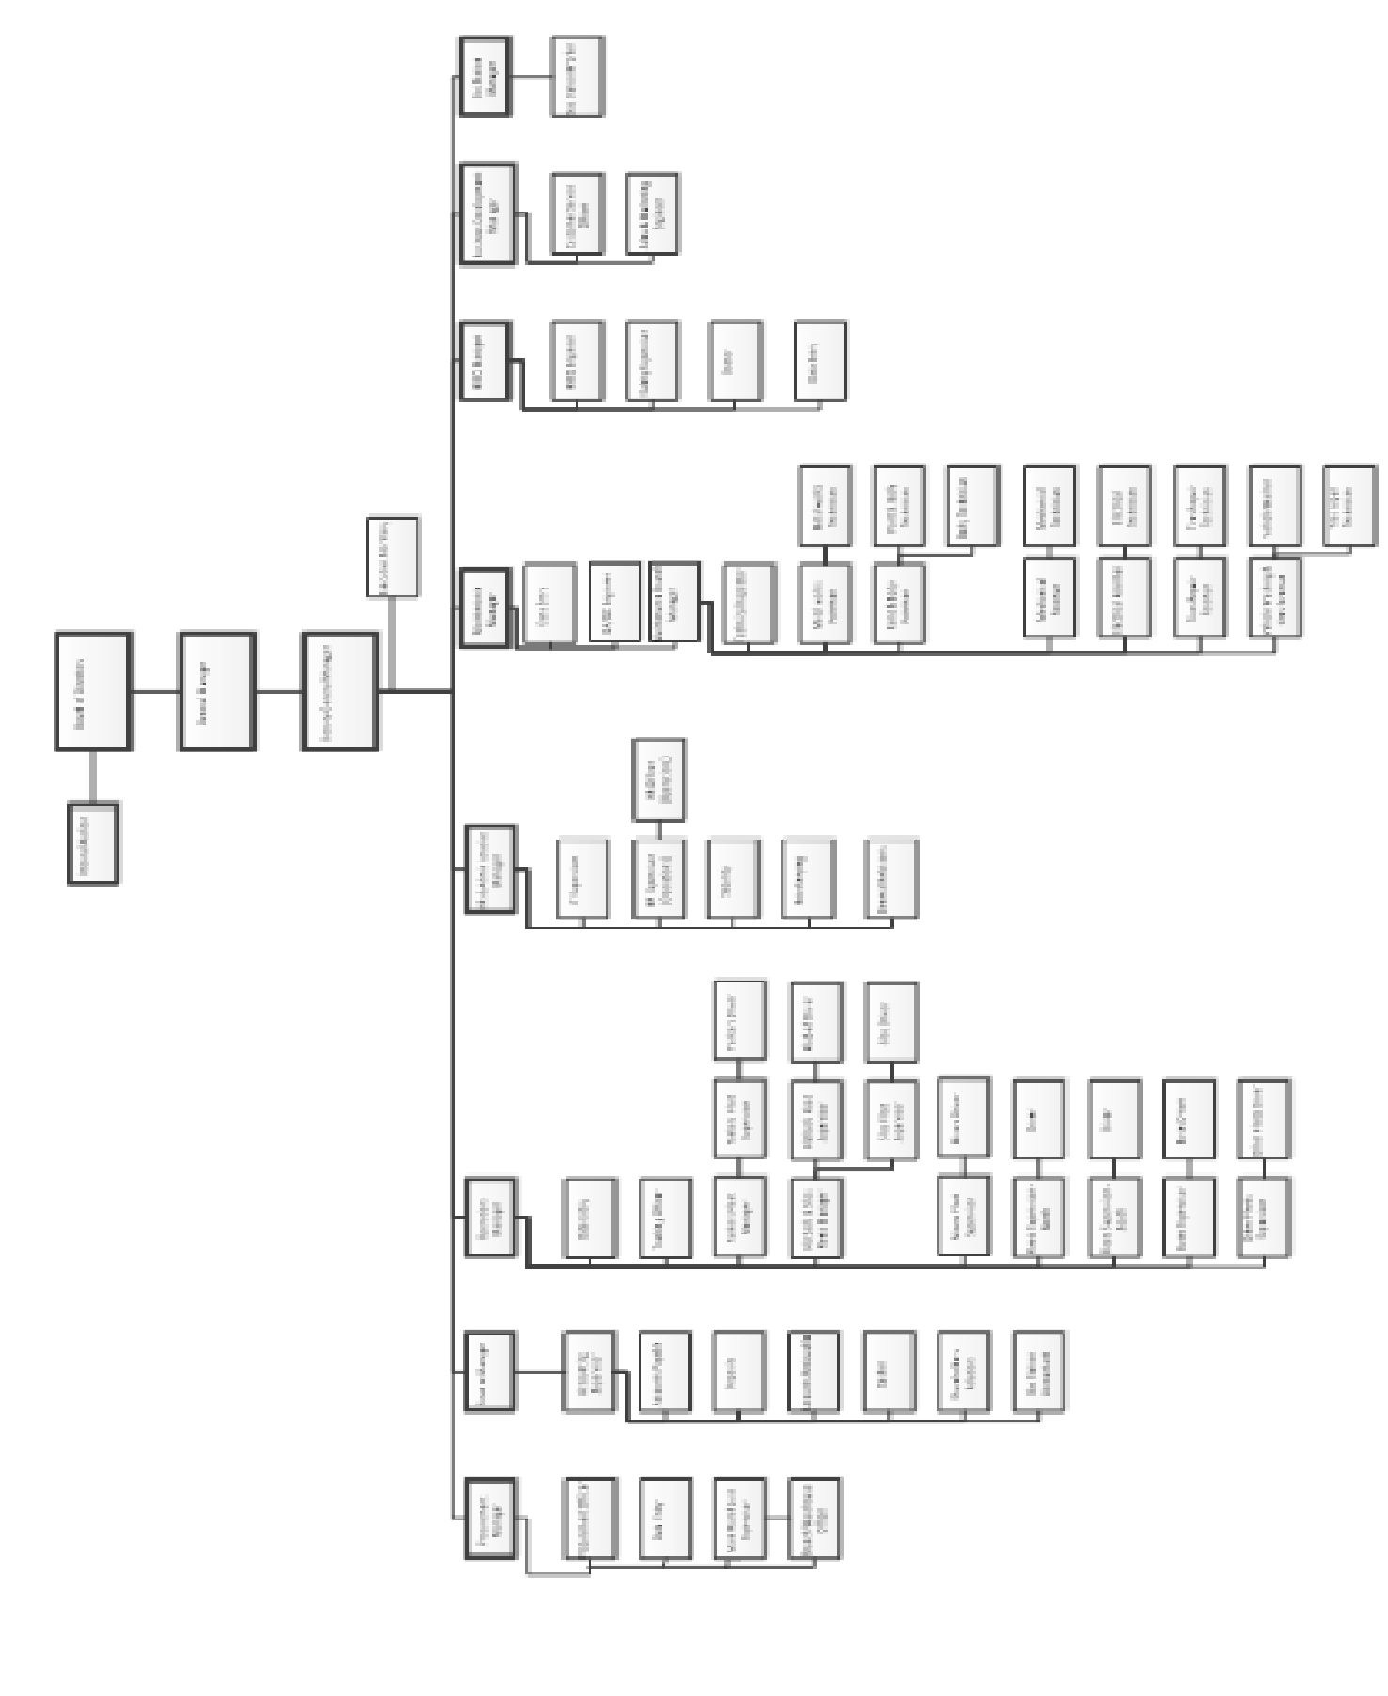

9-B- Number of employees and categories of their qualifications:
Qualifications | The number
Bachelors | 35
Diploma | 23
Guideline and below | 449
Total | 507

9-C-Qualification and training programs for company employees:
Course name | The number
Somulelert | 22
Total | 22

10-There are no risks that the company may be exposed during the next financial year and have a material impact on it.

11-The most important achievements of the company during the year 2025:
- The company's fleet has been increased for transportation services of all kinds.
- Renewal of the ISO Certificate No. 45001 + 9001 + 1400.
- Expanding the company's business.
- Get new transport bids.

12-There is no financial impact of the operations of a non-recurring nature that occurred during the year 2025 and do not fall within the main activity of the company.

13- The time series of realized profits or losses, dividends, net shareholders' equity and prices of securities issued by the company:
Statement | 2025/JD | 2024/JD | 2023/JD | 2022/JD | 2021/JD | 2020/JD | 2019/JD | 2018/JD
Net profits after the tax | 1,293,607 | 1,062,787 | 1,451,911 | 1,071,965 | 775,199 | 183,398 | 768,306 | 668,672
Distributed profits | 740,000 | 740,000 | 925,000 | 740,000 | 647,500 | 555,000 | ---- | 550,000
Free shares | ---- | ---- | ---- | ---- | ---- | ---- | ---- | ----
Net shareholder equity | 24,394,625 | 23,768,784 | 23,532,805 | 22,639,283 | 22,279,115 | 21,987,009 | 21,809,832 | 21,613,624
The closing price of the share | 0.84 | 0.61 | 0.67 | 0.44 | 0.44 | 0.32 | 0.34 | 0.32

*The company was incorporated on 6/3/2006, obtained the right to start working on 7/8/2006, and listed on 8/21/2006.
14- An analysis of the company's financial position and the results of its actions during the financial year:
- Company revenues:
The company's revenues amounted to 32,591,739 JD, distributed as follows:
Statement | 2025/JD
Transport revenue | 32,591,739

- The budget, profits and losses:
- Operating profits amounted to 2,859,234 JD of the total operating income of 32,591,739 JD.
- On 12/31/2024, the company achieved net profits of 1,293,607 JD out of total revenues of 32,591,739.
- Total administrative and financing expenses amounted to 2,481,190 JD.

- The net results of the company's business:
- The net profit achieved by the company after tax amounted to 1,293,607 JD, achieving a return of 0.070 JD / share.

- Profit distribution is as follows:
Statement | 2025/JD | 2024/JD
Mandatory reserve | 153,247 | 127,612
Selection reserve | 142,272 | 109,888
Members of the Board of Directors Bonuses | 45,000 | 45,000
Retained earnings | 1,718,079 | 1,459,995

- Financial ratios:
Statement | 2025 | 2024
Earnings per share | 0.070 JD | 0.060 JD
Return on investment | 3.35% | 2.82%
Return on equity | 5.3% | 4.47%
Return on sales | 3.97% | 3.27%
Net profit before sales tax | 4.77% | 3.94%
ownership percentage | 63.1% | 65%
trade rate | 68.9% | 84.2%
Working capital | )3,722,309( JD | )1,932,784( JD

- Indicators and financial data for the year 2025:
Statement | 2025/JD | 2024/JD
Authorized capital | 18,500,000 | 18,500,000
Subscribed capital | 18,500,000 | 18,500,000
Total assets | 38,642,444 | 37,690,197
Total property rights | 24,394,625 | 23,768,784
Total revenue | 34,392,387 | 34,452,270
Net profit before tax | 1,555,957 | 1,279,460
The closing price of the share | 0.84 JD | 0.61 JD

15-A- The company's future plan:
- Renewing the company's fleet.
- Obtaining new bids.
- Continuing to increase the company's various Services.
- Expansion in all types of transportation.
- Reducing costs in general and maintenance costs in particular.
- Expanding the company's customer base.
- Expanding the car rental business.
- Continue to adhere to public safety requirement.

15-B- Significant future developments and expectations of the Board of Directors:
- The company intends to expand its activities during the year 2026.
16- Audit fees:
- The company's financial statements are audited by Messer. Talal Abu-Ghazaleh Co., as their fees for the year 2025 amounted to 9,860 JD for the Main company, and 3,770 JD for the subsidiary companies.
- The company's auditor does not provide any services to the company other than the regular auditing work.

17-A- A statement of the number of shares issued by the company and owned by members of the Board of Directors and their relatives:
Name | Position | Nationality | The number of shares as of 31/12/2025 | Percentage | Number of Shares as of 31/12/2024 | Percentage
Suhail Jamil Muasher and Brothers Company is represented by his excellency Marwan Jamil Isa Muasher | Chairman | Jordanian | 5,182 | 0.028% | 5,182 | 0.028%
Eng. Raja Khalil Ibrahim Al-Alami | Vice Chairman | Jordanian | 7,000 | 0.038% | 7,000 | 0.038%
Al-Rosha Company for Investment and Trade is represented by Mr. Khalil Anis Khalil Nasr | Member | Jordanian | 5,441 | 0.029% | 5,441 | 0.029%
Imad Hamza Al-Khalili | Member | Jordanian | 10,000 | 0.054% | 10,000 | 0.054%
Jawdat Khalil Ibrahim Al-Alami | Member | Jordanian | 5,700 | 0.031% | 5,700 | 0.031%
Mr. Anas Mahmud Al-Chalabi | Member | Britain | 308,332 | 1.667% | 308,332 | 1.667%
Mansoor Akram Al-Alami | Member | Jordanian | 15,441 | 0.083% | 15,441 | 0.083%
Ready Mix Concrete and Construction Supplies Company represented by Eng. Makram Khalil Ibrahim Al-Alami | Membe | Jordanian | 7,574,106  8,187 | 40.941%  0.044% | 7,574,106  8,187 | 40.941%  0.044%
Dr. Jack Nicolas Kattan | Member | Jordanian | 41,456 | 0.224% | 41,456 | 0.224%
17-B- Shares owned by senior management:
Name | Position | Number of shares  31/12/2025 | Number of shares  31/12/2024
Eng. Makram Khalil Ibrahim Al-Alami | General Manager | 8,187 | 8,187
Mr. Ahmad Jamil Yaseen | Financial Director | ------ | ------
Eng. Mohammad Almamo Yacoub Alkisswani | Operation Manager | ------ | ------
Eng. Mohamed Mahmud Saleem Al-Umari | Maintenance Manager | ------ | ------

17-C- Shares owned by relatives of members of the board of directors and senior management:
Name | Number of shares as of  31/12/2025 | Number of shares as of  31/12/2024
Aya Khalil Al-Alami, wife of Anas Al-Chalabi | 3,853 | 3,853
- Relatives of the remaining members of the board of directors and upper management do not own shares in the company.
- There are no companies controlled by board members and their relatives.
- There are no companies controlled by senior management people and their relatives.
18-A- Benefits and Bonuses obtained by the chairman and members of the Board of Directors:
No. | Name | Position | Transportations allowance | Bonuses
1 | Dr. Marwan Jamil Isa Muasher | Chairman | 9,000 | 5,000
2 | Eng. Raja Khalil Ibrahim Al-Alami | Vice Chairman | 9,000 | 5,000
3 | Mr. Jawdat Khalil Ibrahim Al-Alami | Member | 9,000 | 5,000
4 | Mr. Anas Mahmud Ahmed Chalabi | Member | 9,000 | 5,000
5 | Mr. Imad Hamza Nadeem Al-Khalili | Member | 9,000 | 5,000
6 | Mr. Mansoor Akram Al-Alami | Member | 9,000 | 5,000
7 | Mr. Jack Nicolas Yaqoob Kattan | Member | 9,000 | 5,000
8 | Mr. Khalil Anees Khalil Naser | Member | 9,000 | 5,000
9 | Eng. Makram Khalil Ibrahim Al-Alami | Member | 9,000 | 5,000
18-B-The Benefits and Bonuses obtained by people of higher management:
Name | Job | Salaries | Bonuses
Eng. Raja Khalil Ibrahim Al-Alami | Vice Chairman | ----- | 40,000
Eng. Makram Khalil Ibrahim Al-Alami | General Manager | 198,000 | 100,000
Eng. Mohammad Almamo Yacoub Alkisswani | Operation Manager | 24,600 | 2.050
Mr. Mohamed Mahmud Saleem Al-Umari | Maintenance Manager | 48,000 | 4.000
Mr. Ahmad Jamil Yaseen | Financial Director | 42,000 | 3.500
- Due to the nature of the company’s business, each of the above managers has been assigned a car.
19- Donations and grants paid by the company during the financial year:
The name of the donor | Amount / JD
Scholarships for children of employees | 13,062
Total | 13,062

20- There are no contracts, projects or engagements made by the exporting company with the affiliated, sister, allied companies or with the chairman of the board of directors, the members of the board, the general manager or any employee of the company or their relatives.
21-A- The company does not have any contribution to protecting the environment.
21-B- There is no contribution to the company in serving the local community.
Participation in other companies:
- Investment in the Almutawirah forTelecom and Software Services, the capital of which is 400,000 JD, an amount of 61,460 JD.
- Assas for Concrete Products Company, whose capital is 7,120,000 JD, an amount of 197,154 JD.
- Investment in the International Cards Company, whose capital is 18,000,000 JD, at an amount of 208,725.
- Investment in Al-Quds Concrete Industries Company with a capital of 7,460,026 JD, an amount of 947,443.
- Investment in the Ready-Mix Concrete and Construction Supplies Company, whose capital is 25,000,000 JD, an amount of 414,656 JD.
- Investing in the International Brokerage and Financial Markets Company with a capital of 7,855,726 JD, an amount of 3,933 JD.
- Investing in the Alhijaz For Cement Company with a capital of 600,000 JD, an amount of 94,435 JD.

23-Applying the Guidelines for the Corporate Governance Manual for Listed Companies on the Amman Stock Exchange:
During the year 2017, the company worked to adhere to the application of the guidelines contained in the Corporate Governance Manual for Companies listed in Amman Stock Exchange.
Governance Report
- Information and details related to the application of the provisions and rules of corporate governance:
The commitment to implement the corporate governance instructions for the listed companies, as the company has approved internal governance system from the Board of Directors and according to the corporate governance rules, as follows:
- Formation of the Boards of Directors:
The Board of Directors consists of ten members who are elected according to the cumulative voting method by the general assembly is by secret ballot, the term of the council is four years and all members of the council are persons whom are qualified and have sufficient experience and knowledge of financial and legislative matters.
- Duties and responsibilities of the Boards of Directors:
The Board of Directors has an internal system according to which the duties, powers, and responsibilities of the board are defined through:
- Develop strategies, policies, plans and procedures that will achieve interest of the company and its goals, maximizing the rights of its shareholders, and serving the local community.
- Establishing the necessary procedures to ensure that all shareholders, including non-Jordanians, have their rights and treating them in a manner that achieves justice and equality without discrimination.
- Taking the necessary measures to ensure compliance with the provisions of the legislation in force.
- Adopting a risk management policy that the company may be exposed to.
- Organizing the financial, accounting and administrative matters of the company according to special internal regulations.
- Preparing the annual and quarterly report on the preliminary business results, in accordance with the provisions of the legislation force.
- Approving the corporate governance report and including it in the company’s annual report.
- Setting rules of professional conduct for the Board of Directors, executive management and employees of the company and to be reviewed and updated constantly.
- Ensure that a website for the company is provided, which includes the most important data and information about the company, provided that this information is constantly updated.
- Appointing a liaison officer entrusted with monitoring matters related to corporate governance applications with commission.
- Adopting the company’s disclosure and transparency policy and following up its implementations in accordance with the authority’s requirements of censorship and legislation force.
- Establishing a policy to avoid conflicts of interest and procedures aimed at preventing insiders from the company to exploit confidential internal information for material or moral gain.
- Establishing a clear delegation policy in the company that specifies the authorized persons and limits the powers delegating them.
- Appointing the general manager of the company and terminating his services.
- Ensuring the availability of the necessary administrative and technical competence and expertise in the persons of the higher executive management to carry out the tasks assigned to them, and determine their tasks and powers, and review the performance of their tasks, and the extent of their implementations of established policies, plans and procedures.
- Taking adequate steps to ensure the existence of internal control over the workflow in the company, including the establishment of a special unit for internal control and auditing whose task is to ensure compliance with the provisions of the legislation in force, the requirements of the supervisory authorities, internal regulations, policies, plans and procedures established by the Board of Directors.
- Adopting the replacement and succession policy and the company’s human resources and training policy.
- Establishing a corporate social responsibility policy and its programs towards the local community and the environment.
- Establishing a mechanism to receive the complaints and suggestions submitted by the shareholders, including their suggestions for including specific topics on the agenda of the general assembly meeting in a way that ensures that they are studied and the appropriate decision is taken regarding them within a specific period of time.
- Establishing a mechanism that allows shareholders who own at least 5% of the company's subscribed shares to add items to the agenda of the company's ordinary general assembly meeting before sending it in its final form to the shareholders, provided that the Authority is provided with this mechanism.
- Adopting the policy for granting bonuses, benefits, incentives and salaries in the company.
- Setting a policy to regulate the relationship with stakeholders to ensure the implementation of the company's obligations towards them, preserve their rights, provide them with the necessary information, and establish new relationships with them.
- Memberships of members of the Board of Directors in other public joint-stock companies:
Dr. Marwan Jamil Muasher
- Jordan Kuwait Bank (Board Member)
- Ready-Mix Concrete and Construction Supplies Company (Board Member)
Eng. Makram Khalil Al-Alami
- Ready-Mix Concrete and Construction Supplies Company (Board Member)
- International Brokerage and Financial Markets Company (Chairman)
- International Cards Company (Chairman)
- Assas for Concrete Products Company (Board Member)
Mr. Khalil Anees Khalil Naser
- Emaar Development and Real Estate Investment Company (Vice Chairman)
Mr. Jawdat Khalil Al-Alami
- International Brokerage and Financial Markets Company (Board Member)
- Assas for Concrete Products Company (Board Member)
- Al-Quds Concrete Industries Company (Board Member)
Eng. Anas Mahmud Chalabi
- International Brokerage and Financial Markets Company (Board Member)
- Assas for Concrete Products Company (Board Member)
- Ready-Mix Concrete and Construction Supplies Company (Board Member)
Eng. Raja Khalil Al-Alami
- Ready-Mix Concrete and Construction Supplies Company (Board Member)
- Assas for Concrete Products Company (Chairman)
- International Brokerage and Financial Markets Company (Board Member)
Mr. Mansoor Akram Al-Alami
- International Brokerage and Financial Markets Company (Board Member)
- Contemporary Company for Housing Projects (Board Member)
- Al-Quds Concrete Industries Company (Board Member)
Dr. Jack Nicolas Yaqoob Kattan
- The Jordan Worsted Mills Company (Board Member)
- Arab International Hotels Company (Board Member)
- Al-Zee Company for the manufacture of ready-to-wear clothes (Board Member)
- The rest of the members of the board do not have memberships in the boards of directors of any of the other public joint-stock companies other than Masafat Specialized Transportation Company.
- The names of the members of the Board of Directors for the year 2025:
Name | Executive or Non-Executive | Independent or not Independent
Dr. Marwan Jameel Muasher | Executive | Independent
Mr. Khalil Anees Khalil Naser | Non-Executive | Independent
Mr. Jawdat Khalil Al-Alami | Non-Executive | Not Independent
Mr. Imad Hamza Al-Khalili | Non-Executive | Independent
Mr. Anas Mahmud Ahmed Chalabi | Non-Executive | Independent
Mr. Mansoor Akram Al-Alami | Non-Executive | Independent
Eng. Makram Khalil Al-Alami | Non-Executive | Not Independent
Dr. Jack Nicolas Kattan | Non-Executive | Independent
Eng. Raja Khalil Al-Alami | Non-Executive | Not Independent

* There are resigned members during the year 2025

- Committees emanating from the Board of Directors:
- The Audit Committee.
- Bonuses and Benefit Committee.
- Governance Committee.
- Risk Committee.
- Names of the chairman and members of the committees emanating from the council:
- The Audit Committee:
Mr. Imad Hamza Al-Khalili - Committee president
Eng. Raja Khalil Al-Alami – Member
Dr. Jack Nicolas Kattan– Member
- Bonuses and Benefit Committee:
Mr. Khalil Anees Naser - Committee President
Eng. Makram Khalil Al-Alami – Member
Mr. Anas Mahmud Al-Chalabi – Member
- Governance Committee:
Mr. Anas Mahmud Al-Chalabi – Committee President
Mr. Marwan Jamil Muasher – Member
Eng. Makram Khalil Al-Alami – Member
- Risk Committee:
Dr. Jack Nicolas Kattan – Committee President
Mr. Jawdat Hamza Al-Khalili – Member
Mr. Mansoor Akram Al-Alami– Member
- Executive positions and the names of their occupants:
- General Manager Eng. Makram Khalil Al-Alami
- Financial Director Mr. Ahmed Jamil Yaseen.
- Operations Manager Eng. Mohammad Almamo Yacoub Alkisswani
- The director of the maintenance department Eng. Mohamed Mahmud Al-Umari.

- The names of the legal members of the Board of Directors:
Name | Executive or Non-Executive | Independent or not Independent
His Excellency Dr. Marwan Jamil Muasher representative of Suhail Jamil Muasher and Brothers Company. | Non-Executive | Independent
Mr. Khalil Anees Khalil Naser representative of Al-Rosha Company for Investment and Trade. | Non-Executive | Independent
Eng. Makram Khalil Al-Alami representative of Ready-Mix Concrete and Construction Supplies Company. | Executive | Not Independent

- The number of meetings of each of the committees formed by the Board of Directors during the year2025:

Board of Directors | Board meetings | Number of attendances
Dr. Marwan Jamil Muasher | 11 | 11
Eng. Raja Khalil Al-Alami | 11 | 11
Mr. Jawdat Khalil Al-Alami | 11 | 11
Mr. Imad Hamza Al-Khalili | 11 | 11
Dr. Jack Nicolas Kattan | 11 | 11
Eng. Makram Khalil Al-Alami | 11 | 11
Mr. Anas Mahmud Chalabi | 11 | 11
Mr. Mansoor Akram Al-Alami | 11 | 11
Mr. Khalil Anees Naser | 11 | 11

Audit committee | Number of meetings | Number of attendances
Dr. Jack Nicolas Kattan | 4 | 4
Mr. Imad Hamza Al-Khalili | 4 | 4
Eng. Raja Khalil Al-Alami | 4 | 4

Risk Committee | Number of Meetings | Number of attendances
Mr. Mansoor Akram Al-Alami | 2 | 2
Mr. Imad Hamza Al-Khalili | 2 | 2
Dr. Jack Nicolas Kattan | 2 | 2

Governance Committee | Number of Meetings | Number of attendances
Mr. Anas Mahmud Al-Chalabi | 2 | 2
Mr. Marwan Jamil Muasher | 2 | 2
Eng. Makram Khalil Al-Alami | 2 | 2

Benefits and Bonuses Committee | Number of Meetings | Number of attendances
Eng. Makram Khalil Al-Alami | 2 | 2
Mr. Khalil Anees Naser | 2 | 2
Mr. Anas Mahmud Al-Chalabi | 2 | 2

- FOUR meeting was held between the Audit Committee and Talal Abu-Ghazaleh, the external auditor of the company's accounts.
- Mr. Ahmad Jamil Yaseen has been appointed as a liaison officer to follow up matters related to the application of governance at the company, led by the Securities Commission.

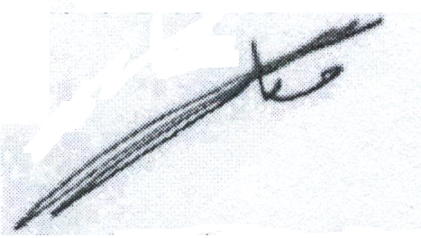

Dr. Marwan Jamil Al-Muasher
Chairman of the Board of Directors

Board of Directors recommendation for the general assembly meeting
- Recitation of the proceedings of the previous ordinary meeting of the General Authority.
- Reading the report of the Board of Directors of the fiscal year 2024 and discussing the future plan of 2026.
- Listening to the company’s auditors report on its budget and final accounts for the year 2025
- Discussing the balance sheet and closing accounts for the ended fiscal year of 31/12 2025 and approving it.
- Discussing the decision of the Board of Directors to distribute the dividends to the shareholders at the rate of 4%.
- Discharge the Members of Board of Directors.
- Election of the auditor for the fiscal year 2026 and determining their fees or authorize the Board of directors to determine their followers.
- Any other matter that the General Authority Proposes to be included in the agenda according to the provisions of the article (171) from companies’ law.
Honorable Shareholders,
The Board of Directors, after hearing its report, is pleased to extend sincere thanks to all shareholders and customers for their confidence and continuous support for the company.

The Board appreciated all the Company’s management, employees, and workers for their services and sincere efforts to achieve the goals and objectives of the company. We wish them progress and prosperity, praying to Almighty Allah to protect this dear nation under the guidance of His Majesty King Abdullah II Ibn Al Hussein

Board of Directors

Company Board of Directors
- The Board of Directors declares that there are no more material matters that may affect the continuity of the company during fiscal year 2026.
- The Board of Directors acknowledges its responsibility for preparing financial the statements for the year 2025or their availability of an effective monitoring system in the company

- Gentlemen Suhail Jami Muasher and Brothers company is represented by . Dr. Marwan Jamil Essa Al-Muasher
Chairman of Board of Directors
Eng. Raja Khalil Ibrahim Al-Al-Alami Eng. Anas Mahmoud Al-Chalabi
Deputy Chairman of Board Member
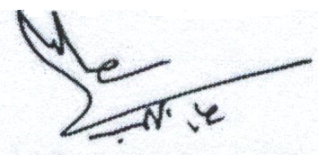
Mr. Emad Hamza Nadim AL Khalil Dr. Jack Nicolas Yaqoob Kattan
Member Member 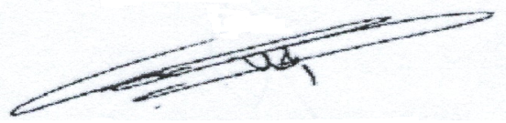 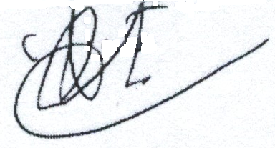
Mr. Jawdat Khalil Ibrahim Al-Alami Kingdom Concrete company and construction
Member supplies Is represented by Member
Eng. Makram Khalil Ibrahim Al-Alami
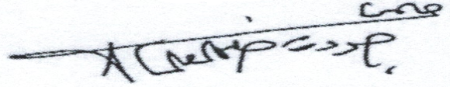

Mr. Mansoor Akram Badawi Al-Alami AL Rouche for Investments and
Member Trading Company represented by
Mr. Khalil Anis Khalil Naser, Member
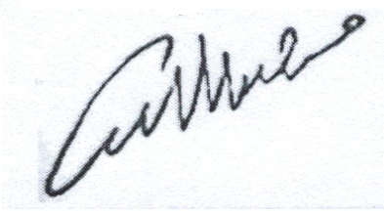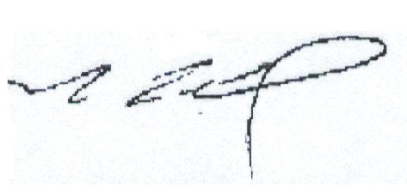

Acknowledgement

We acknowledge the validity, accuracy, and completeness of the information and data contained in the annual report for the ending year 31/12/2025.

- . Dr. Marwan Jamil Essa Al-Muasher

Chairman of Board of Directors

General Manager Financial Director

Eng. Makram Khalil Ibrahim Al-Alami Mr. Ahmad Jamil Yassin



